Auckland Seventh-Day Adventist High School | 

Digital Technologies
Internal Assessment
Achievement Standard AS91903 and AS91907

Standard Title:  AS91903 AS91907 | Use complex techniques to develop a digital outcome (4 credits)  Use complex processes to develop a digital technologies outcome (6 credits)
Credits | 10 | Level | 3 | Assessment | Internal
Reference | Digital Technologies | Hangarau Matihiko 3.8

Achieved (A)/ Paetae | Merit (M)/ Kaiaka | Excellent (E)/Kairangi
Use complex processes and techniques to develop a digital technologies outcome | Use complex processes and techniques to develop an informed digital technologies  outcome | Use complex processes techniques to develop a refined digital technologies outcome

Level of performance:

Authenticity Statement
Student: I understand that the work I submit for this assessment must be my own. I understand that if it was appropriate to source information, it must be acknowledged appropriately. I understand that I may be required to identify my sources if there is any question about the authenticity of this work. I have acknowledged that plagiarism and/or collusion will result in disciplinary action, which may make me ineligible for a grade in this standard.

Student Name: | Samantha Isabelle De Guzman | Whanau Class: | 13-SJ

Auckland Seventh-Day Adventist High School

Introduction/Kupu Arataki
This assessment activity requires you to plan and create a website with a well-designed homepage and multiple pages. You will be assessed on the iterative improvements made throughout the development and testing process, as well as your use of efficient tools and techniques in producing the final outcome.

Task/ Hei Mahi
You are tasked with creating a multi-page website on a theme that you care about, such as the environment, youth mental health, developing safer communities, careers, culture, and heritage. The website must include a well-designed homepage, multiple pages with relevant content, and follow website design conventions for readability and navigation. You will use complex tools and techniques, such as custom code or third-party libraries, while ensuring the site is responsive and optimized for web use. Throughout the process, you must identify the purpose and target users, apply testing procedures, and iteratively improve the site based on feedback. Additionally, you will address relevant implications, including legal, ethical, and accessibility considerations, and provide evidence of your testing and improvements, such as screenshots or screencasts. The outcome should demonstrate efficient use of tools, thoughtful design, and adherence to web standards.

Auckland Seventh-Day Adventist High School | 

Use complex processes and techniques to develop a digital technology outcome  involves: |  |  | A
A1 | Using recognised and appropriate project management tools and techniques to plan the development of a  digital technology's outcome | - Kanban  - Agile Methodology  - Trello
A2 | Decomposing the digital technologies  outcome into smaller components | - Table of components (MVP)  - List of components (photo)
A3 | applying appropriate tools and techniques to meet the purpose and end-  user requirements | - Student must complete a table with the tools they will use. Explain pros  and cons. Why do you think it is appropriate.
A4 | Trialling components of the outcome.  Applying appropriate data integrity and testing procedures. | - Fill a table (Trailing)  - Describe the testing (How do you test your components)
A5 | Testing that the digital technologies outcome functions as intended.  Apply user experience principles  relevant to the purpose of the outcome. | - Develop different test and fill the table.  - Describe your UX and how do you apply it.
A6 | Explain relevant implications. | - Describe Relevant implications.
Use complex processes and techniques to develop and informed digital technologies  outcome: |  |  |  | M
M1 | effectively using project management tools and techniques to manage development, feedback and/or  collaborative processes | - Evidence of feedback and iterative process (Updating frequently). Evidence of documenting process and  collaborative.
M2 | Effectively trialling multiple components and/or techniques | - Students show evidence of  - Select a component, 2. Plan 3.  Make, 4. Trial 5. Change.
M3 | Effectively using information from testing and trialing to improve the functionality of the digital technologies Outcome.  Using information from testing procedures to improve the quality of  the digital media outcome | - Describe how you use the feedback from the end users.  - Describe how you use information from testing procedures to improve the quality of the digital outcome. And how do you apply to UX?
M4 | Addressing relevant Implications | Explain how the R.I was addressed

Use complex processes techniques to develop a refined digital technologies outcome  involves: |  |  |  |  | E
E1 | synthesising information gained from the planning, testing, and trialling of components | - Summarize how the information from planning, testing, and trialing of components assisted in the  development of a high-quality outcome.
E2 | discussing how this information led to the development of a high-quality  digital technologies outcome. | - Discuss how the information from planning, testing, and trialing of components assisted in the  development of a high-quality outcome.
E3 | using efficient tools and techniques in the outcome’s production. | - Shows evidence of the use of efficient tools and techniques to develop your  prototype.
E4 | Iterative improvement throughout the design, development, and testing process to produce a high-quality  outcome | - Evidence of the iterative trial.  Annotated screenshots must be included.

For Excellence, iterative improvement requires that students develop a functional outcome using documented cycles of improvement. This may include adding features to the outcome. Student evidence needs to show deliberate cycles of improvement based on testing and trialing, rather than just incremental development.
Iterative improvement goes beyond just debugging or correcting errors in a non-functioning outcome. It is expected that the student will produce a functioning outcome for an Achieved grade. Iterative improvement should be aimed at making a better product, and evidence of the improvement needs to be provided.
Students may be able to provide sufficient evidence of the development of the outcome. Examples of this include annotated screenshots, ‘commit’ messages and comments made within the source files, all related to the outcome. Student evidence does not need to contain all previous versions of the outcome. Evidence should show the existence of previous versions and ensure that the definitive version is clearly labelled, to include comments, and that it functions as expected.

Final grades will be determined on a holistic examination of the evidence provided against the criteria in the achievement standard.
Comments:

Digital Technologies
Evidence – Develop a Digital Outcome AS91903
Digital Outcome Website: https://github.com/sawwamii/TimeCheck-
The website I developed called TimeCheck is about how New Zealand children can switch their daily digital screen time into doing creative and fun recreational activities. It aims to let them discover activities that pique their interest by inputting the number of hours they spent on apps on their mobile phones or gadgets every day. It addresses the problem studied by the University of Otago wherein most New Zealand children at the age of 12 years old spend a third of their after-school time on their mobile phones, often exceeding 8 p.m., which contributes to damaging their well-being. Mostly, TimeCheck targets New Zealand children between ages 8 to 15 years old who spend their entire afternoon glued to their mobile phones and gadgets.
I. Project Management
Task 1: Project Management Tools
- Trello: https://trello.com/b/tlxMiamO/digital
Trello is the first chosen project management tool which helped me to oversee and sort out my tasks for my project. It is a visual collaboration project management tool that features a digital bulletin board with a Kanban-style layout that allows users to create list with cards that correspond to different tasks to accomplish on the set deadline. For my digital board, I created four lists which are:
- To Do: For tasks that are to be done;
- Doing: For tasks that are currently being done;
- Done: For tasks that have been done, and;
- Website: For specific tasks that are not for any of the pages of the website.
Each list had different cards corresponding to different tasks such as developing the website pages and doing sample functionality tests. Each card was updated with initial outcomes and changes made for that task through comments and the finalised outcome placed in the card’s description. Once a task has been completed, it will be marked completed with the checkbox found on its respective card. With Trello, I ensured that all tasks for the project are being tracked and organized to achieve the best version of my project.

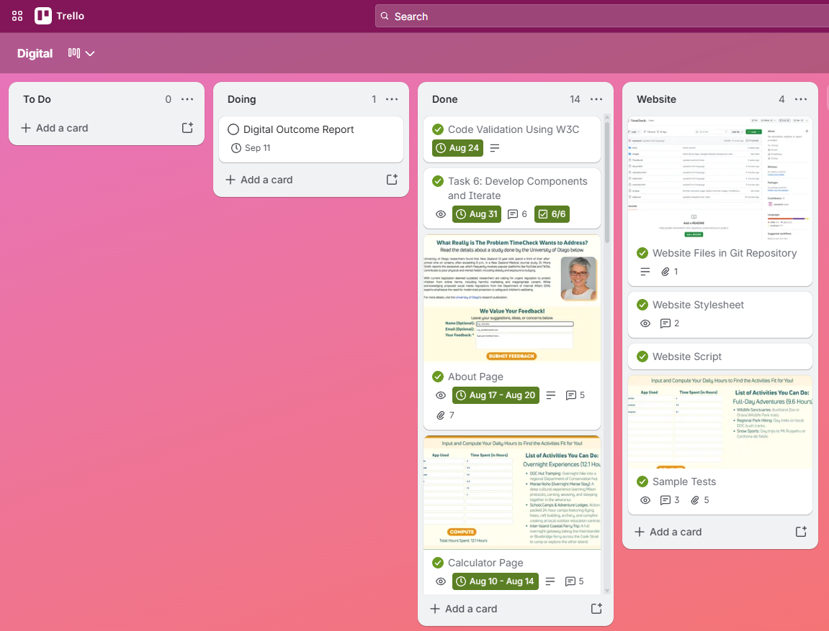

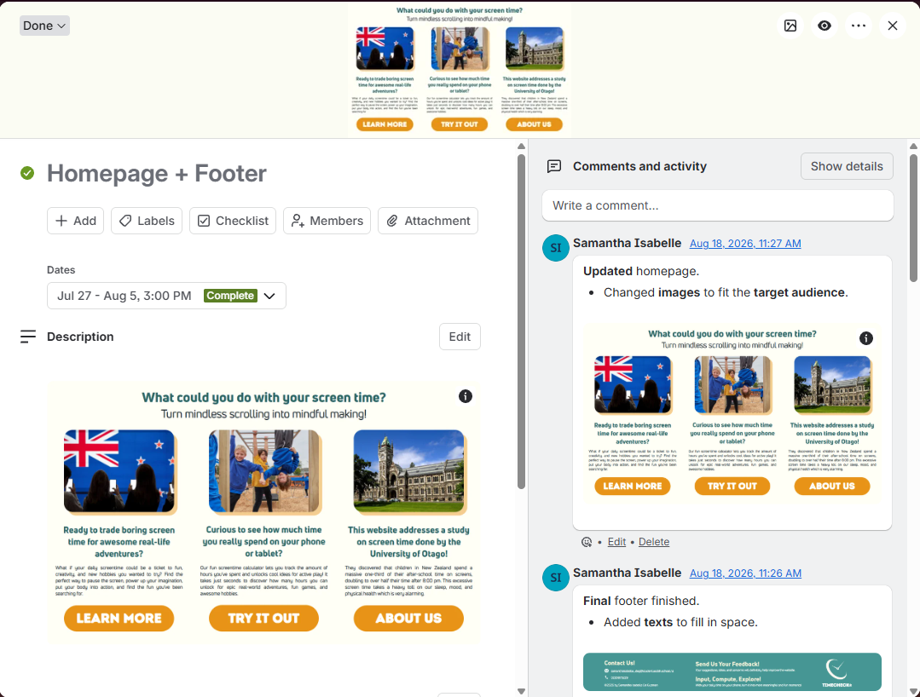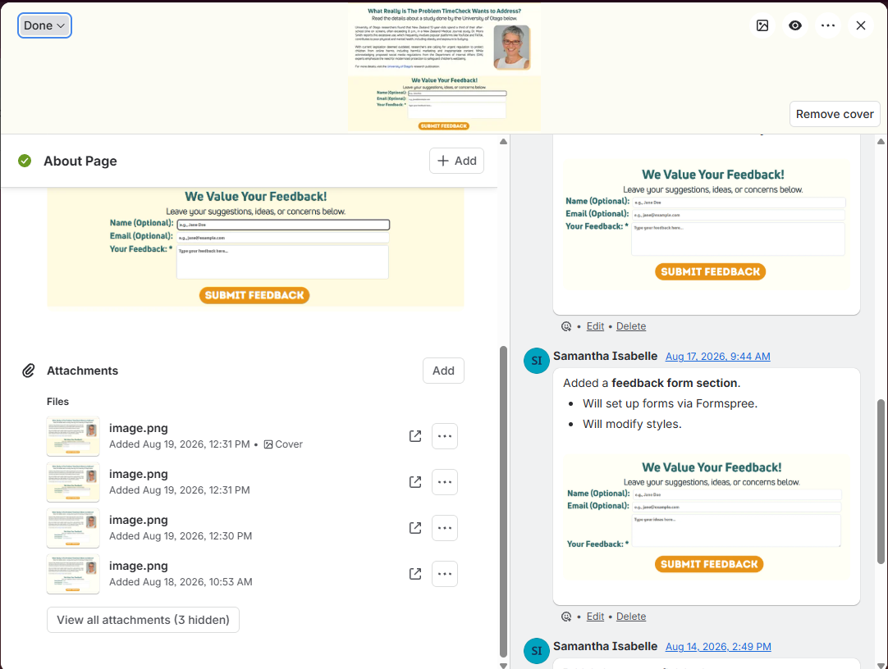
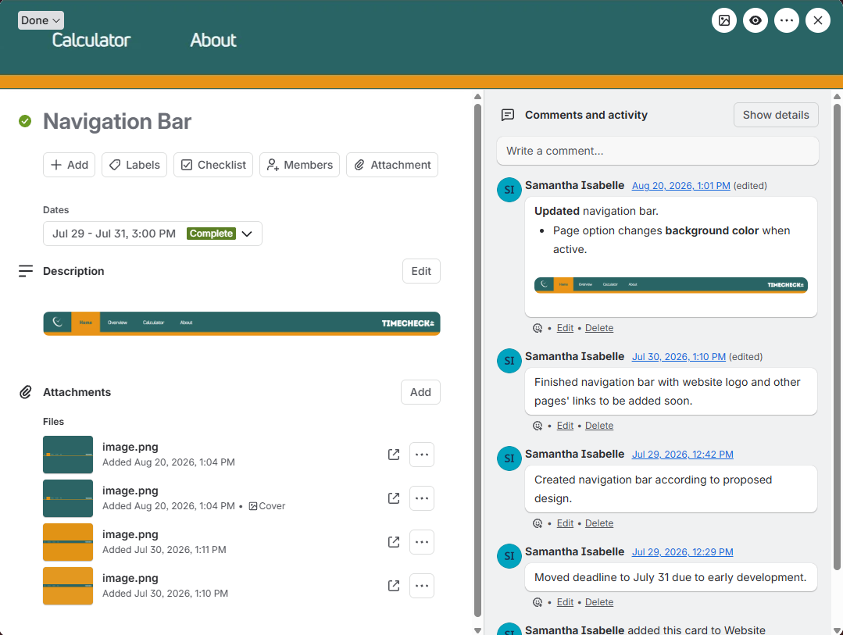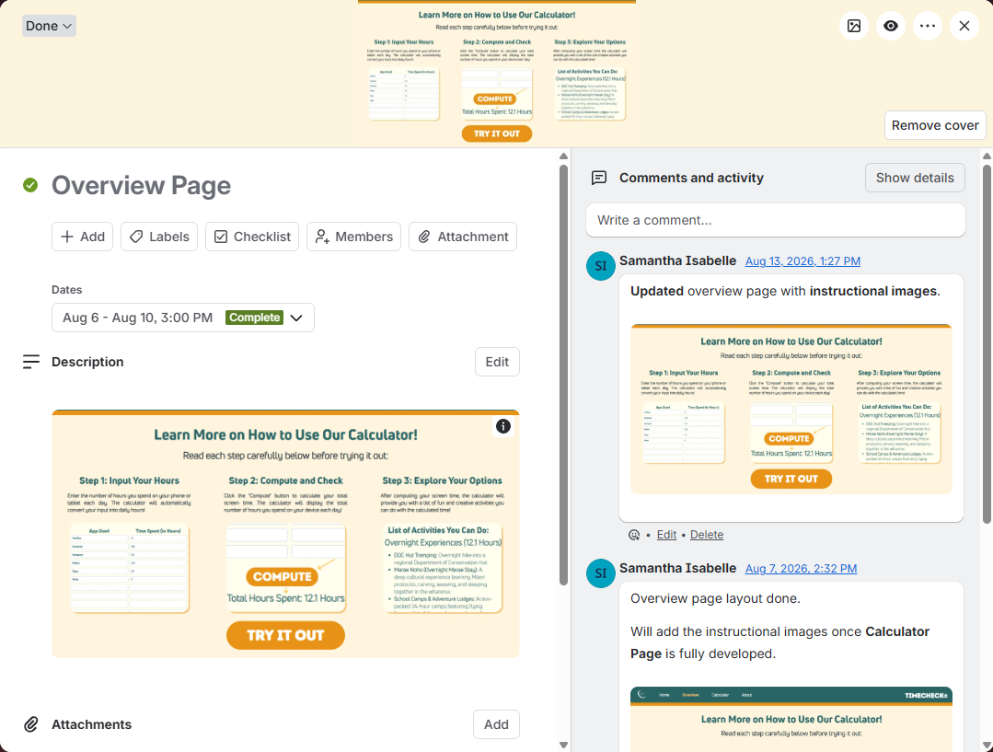
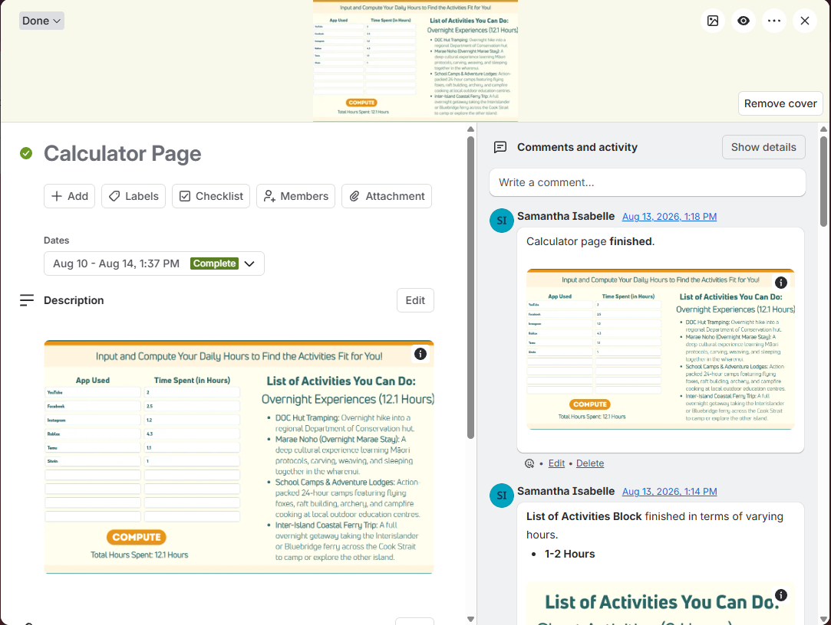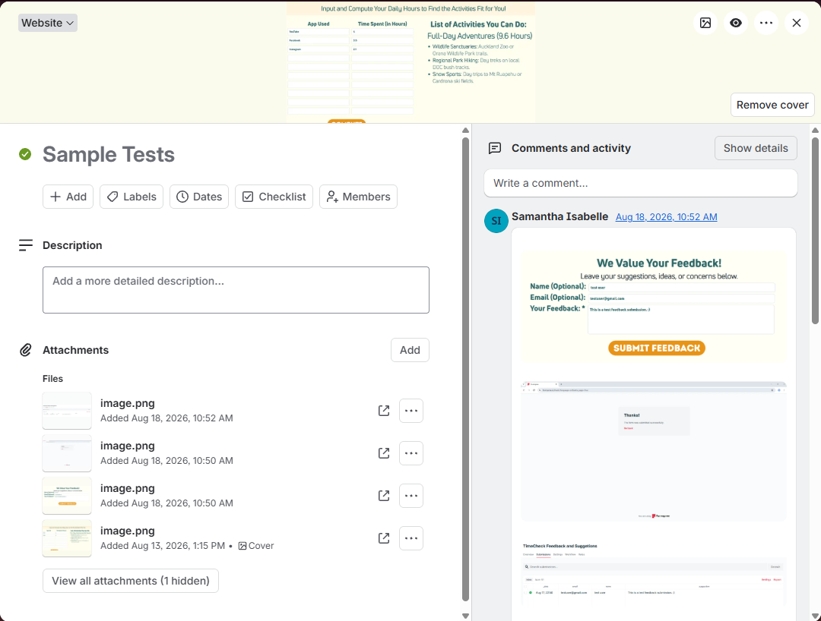

- GitHub: https://github.com/sawwamii/TimeCheck-/commits/main/
GitHub is the second chosen project management tool which helps me manage the code files for my project. A public repository was made for me to upload and update the code files and keep track of the commits recorded in the commits history. With this, I can check what I changed in the code files and compare the older versions to the updated versions.
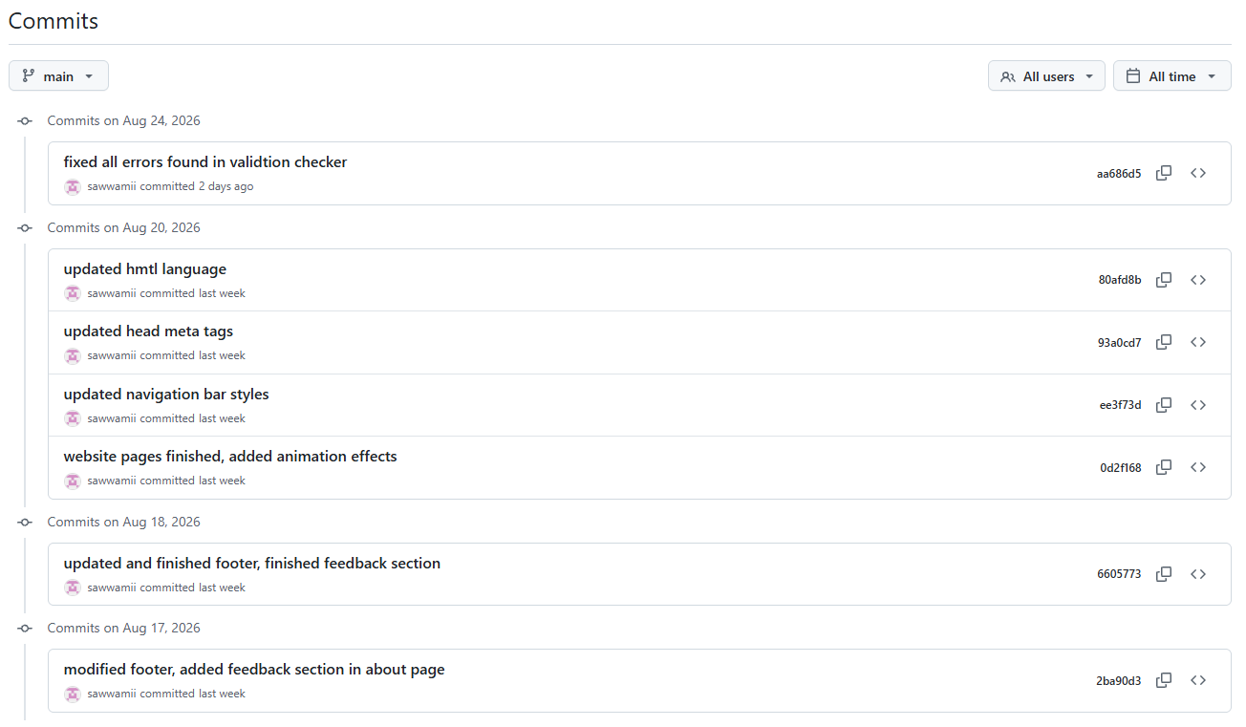
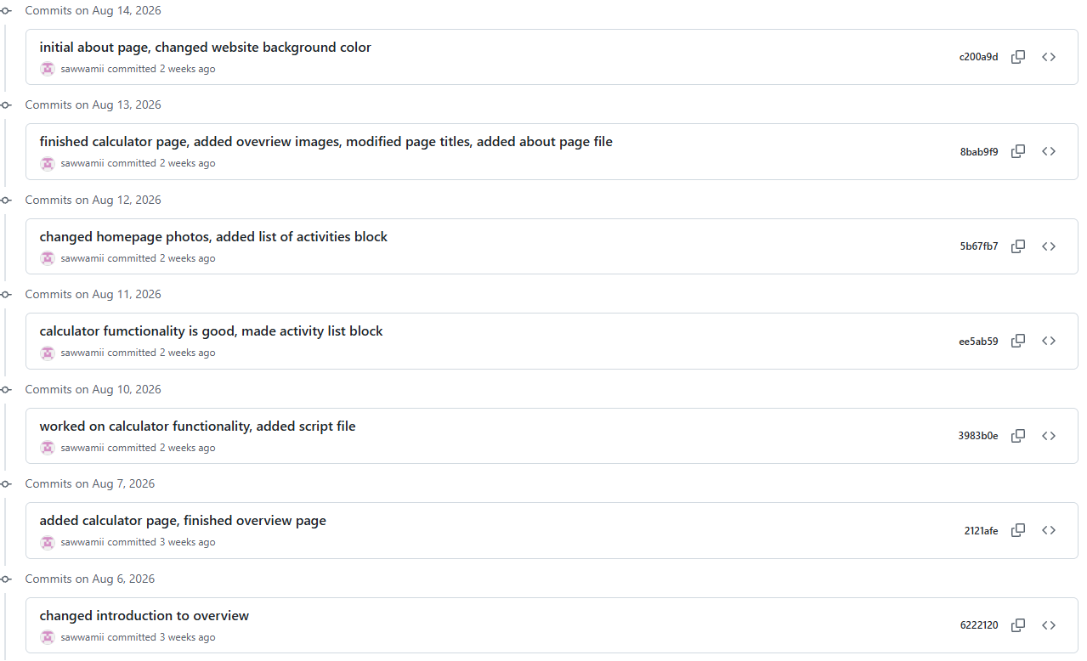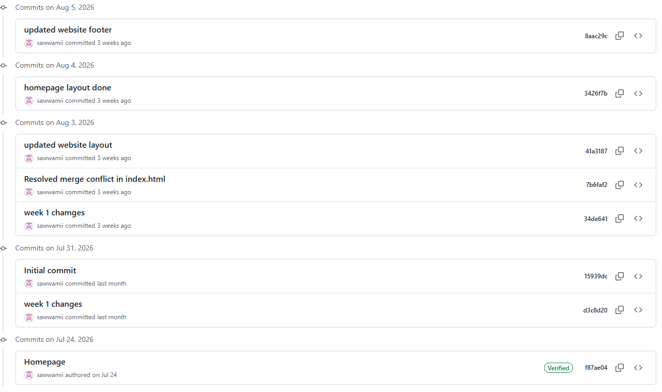
Task 2: Project Management Technique
To properly manage my website project, I chose to follow the Waterfall Technique as it is done in a step-by-step procedure wherein the steps are grouped into subgroups of steps for me to keep track of. As shown below, each step was beneficial in managing my project:
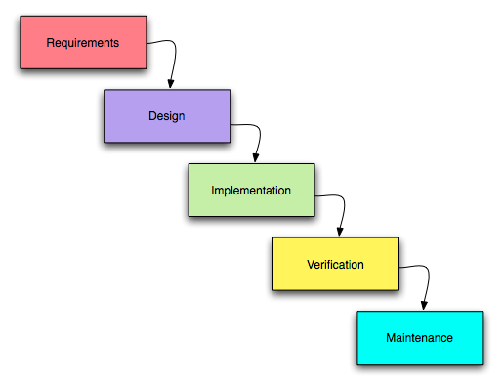
- Requirements - I checked what my project needed and divided each task with their respective deadline and goal.
- Design - I planned to design my project using a designing tool software (Canva) so I can have a preview of how I envision my project to be.
- Implementation - After the designing step, I developed my project through coding in HTML, CSS, and JavaScript and followed the tasks I had set for the implementation process using Visual Studio Code.
- Verification - During the project development process, I did multiple verification tests on the code files check their functionality and rating from the validation services of HTML and CSS to see if there were any errors present for me to go back and iterate them.
- Maintenance - Once the project was ready and considered final, the website will continue to receive bug fixes and constant updates based on future feedback given by the users.
With the waterfall project management technique, this helped me map out my project development tasks and develop and iterate my project based on the provided feedback to achieve the best version of the website.
Task 3: Project Development Tools
Before proceeding with the development of my project, I gathered other project development tools that are relevant and beneficial for the development process. Below are the following:
Tool | Purpose | Pros | Cons
Trello | A management tool to organize tasks using a visual board to see what is needed to do, ongoing, and done. | - Easy to use and straightforward - Features a virtual visual board - Can invite collaborators | - A bit tricky to use for beginners
GitHub | A version control tool that tracks the changes made for the code files using Git. | - Can invite collaborators | - Difficult to use and locate repositories when not familiarized
Visual Studio Code (VS Code) | A code editor developed by Microsoft to write, edit, and debug programmed code files in HTML. CSS, and JavaScript. | - Fast and lightweight - Contains a built-in terminal and Git - Can run on all computers | - Difficult to set up for beginners - Limited tools for heavy coding
HyperText Markup Language (HTML) | A programming language that formulates the skeleton or structure and organize the contents of the website. | - Easy to use for beginners - Highly accessible and free - Universally supported in any web browser - Can easily be integrated with CSS and JavaScript | - Heavy coding for complex websites - Limited styling features - Cannot control logical and conditional events
Cascading Style Sheets (CSS) | A stylesheet language that helps improve the visuals and aesthetics of the website. | - Enhances the design of the website elements - Can set general and specific designs for elements - Features advanced styling such as animations and transitions | - Heavy coding for complex websites 2. Overlapping styles for an element can cause conflict
JavaScript | A programming language that controls the logic and conditions of certain elements of a website. | - Makes website elements functional and interactive | - Heavy coding for complex websites
Canva | A designing software tool that creates different types of media using visual elements such as text, graphics, and images. | - Easy to use for beginners - Can invite collaborators - Features a free library of elements to use | - Limited advanced tools - Paid subscription to access other features and elements
Photos App | A software app that can edit images. | - Easy to use and accessible to all computers | - Limited tools for image enhancement
With these project development tools I had chosen, they assisted me in planning, developing, and iterating the tasks I had set for my project. After setting up Trello and GitHub, I proceeded to using the Photos App to resize and edit images needed for the website, and Canva to map out the design I envisioned my website to look like before putting into code. Once the design was satisfactory according to what I thought the target audience would appreciate, I proceeded to VS Code to work on developing the code files. I used HTML to create the framework of the website and sorting the website pages into different HTML files (.html). I then used CSS by creating a stylesheet file (.css) to input all the styling conventions for the elements on each page. JavaScript was then used by creating a script file (.js) where all the functionality and logical statements for interactive elements were programmed. Overall, these tools were the perfect toolkit to use in developing my website project.
II. Decomposing Your Digital Outcome
Task 4: Mind Map of Full Digital Outcome
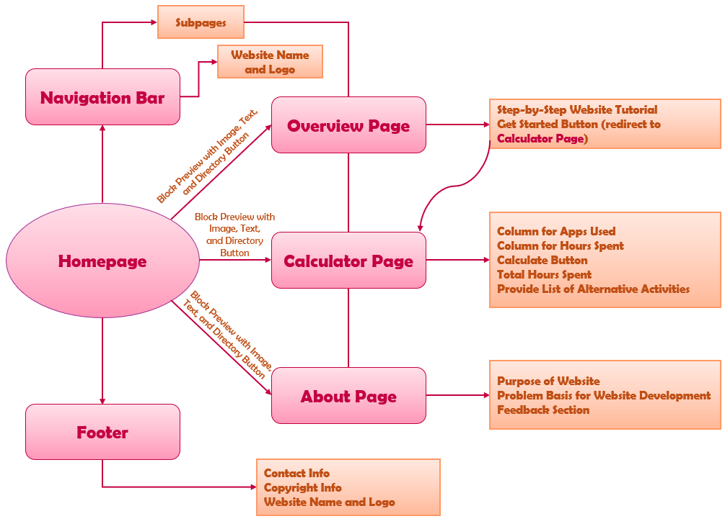
The mind map (or flowchart) shown above comprises of the required components for my website. The following components have their respective elements and subcomponents:
- Homepage (index.html) – The starting page which contains the heading, navigation bar, footer, and block previews of each subpage: Overview, Calculator, and About.
- Navigation Bar – It consists of shortcut hyperlinks to each subpage and the website’s name and logo.
- Footer – It consists of the contact and copyright information and the website’s name and logo.
- Overview – A subpage that contains the step-by-step tutorial in how to use the website and a button to take the user to the Calculator subpage.
- Calculator – A subpage that contains the functional calculator for the user to input and compute their daily screen time and find alternative activities they can do for the calculated amount of time.
- About – A subpage that contains the problem the website wants to address and the feedback section for users to submit their suggestions and concerns regarding the website.
Task 5: List the Components in an MVP Table
Component | Objective | Assets | Rules | Deadline
Homepage | Make an appealing homepage with the website title and condensed version of the introduction page with a button to take them to the full introduction page. | NZ-related images, website logo, intro text, paragraph section, “Learn More” button | Ensure accessibility, easy navigation, and visually appealing for all users. | 1 Week 28th July – 3rd August
Navigation Bar | Provide an easy and accessible navigation bar that can simply redirect the user to their selected page. | Navigation bar, hyperlinks, website logo, page icons (optional) | All text must be readable and easy to navigate. | 3 days 29th July – 31st July
Footer | The footer will have the copyright details of the website. | Copyright text, footer section | Ensure accessibility, easy navigation, and visually appealing for all users. | 3 days 29th July – 31st July
Overview Page | Show the user how to use the website and a button to help redirect the user to the calculator page. | Paragraph section, text, “Try it Out” Button | Elements must be visually appealing and readable for the user. | 1 Week 6th August – 13th^{th} August
Calculator Page | Display an appealing calculator with two columns: one for the apps used and another for the number of hours spent on each app, and a calculate button. | Table for user to input, text, “Calculate” button, lists of activities | Ensure calculator functions properly and must calculate the total correctly. | 1 Week 13th August – 21st August
About Page | Place a section explaining the problem of New Zealand kids having huge amount of screen time and how it can be prevented through alternative activities. A feedback section will be included for the user to send feedback. | Related images, paragraph sections, text, input section, send button | Information displayed must be researched using a reliable study/source. Photo sources must be provided. Feedback section data must be stored. | 5 days 21st August – 25th August

III. Develop and Iterate Components
Iteration 1 – 31st July 2026
Component Tested | What I Did | Expected Result | Fail/  Pass | Reason for Fail/Pass | Proof (if Pass)/  What I Must Do (if Fail)
Homepage | - Created index.html  - Created styles.css  - Added heading  - Added subheading  - Added block previews with images  - Added styles in styles.css  - Connected styles.css to index.html | - Heading displays  - Subheading displays  - Block previews with images displays  - Styles inputted displays | Pass | - Uploaded images  - Did coding correctly  - Connected styles.css using <link> tag | 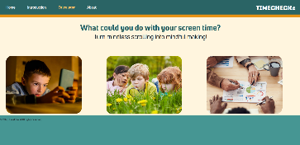  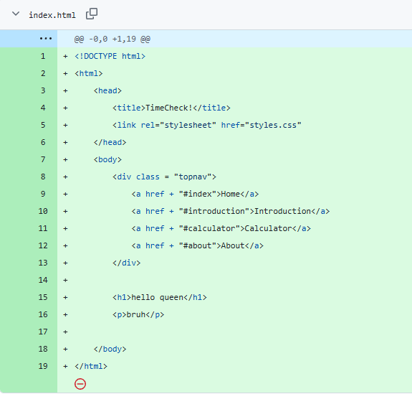  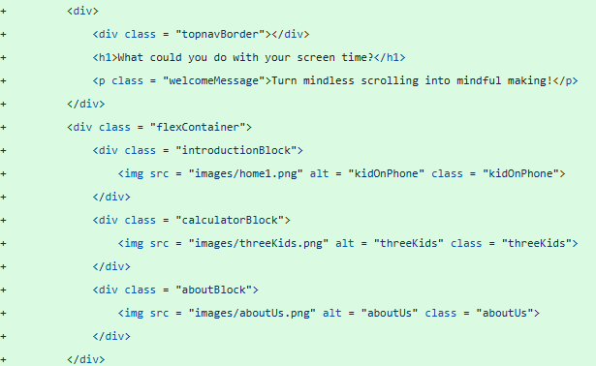
Navigation Bar | - Created nav bar in index.html  - Added div for hyperlinks  - Added style in styles.css | - Nav bar displays  - Styles inputted displays | Pass | - Did coding correctly | 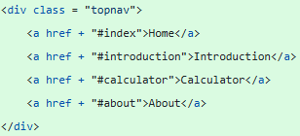

Iteration 2 – 3rd August 2026
Component Tested | What I Did | Expected Result | Fail/  Pass | Reason for Fail/Pass | Proof (if Pass)/  What I Must Do (if Fail)
Homepage | - Added text paragraphs for block previews  - Added directory buttons for each subpage in block previews  - Added styles in styles.css | - Text paragraphs display  - Directory buttons display  - Styles inputted displays | Pass | - Did coding correctly | 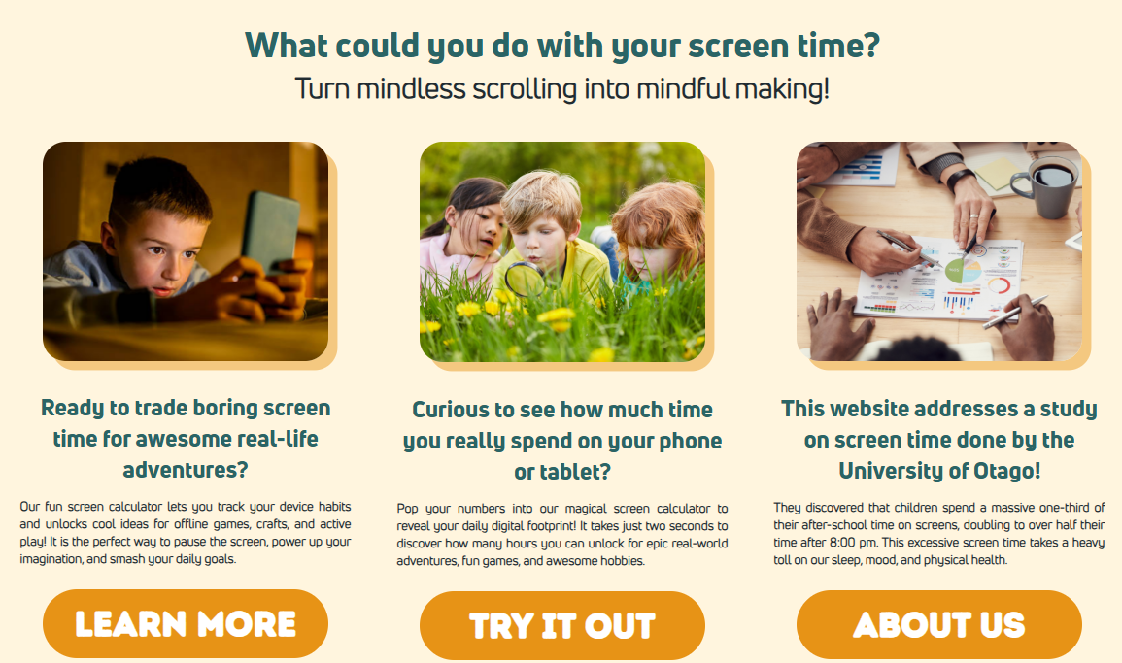  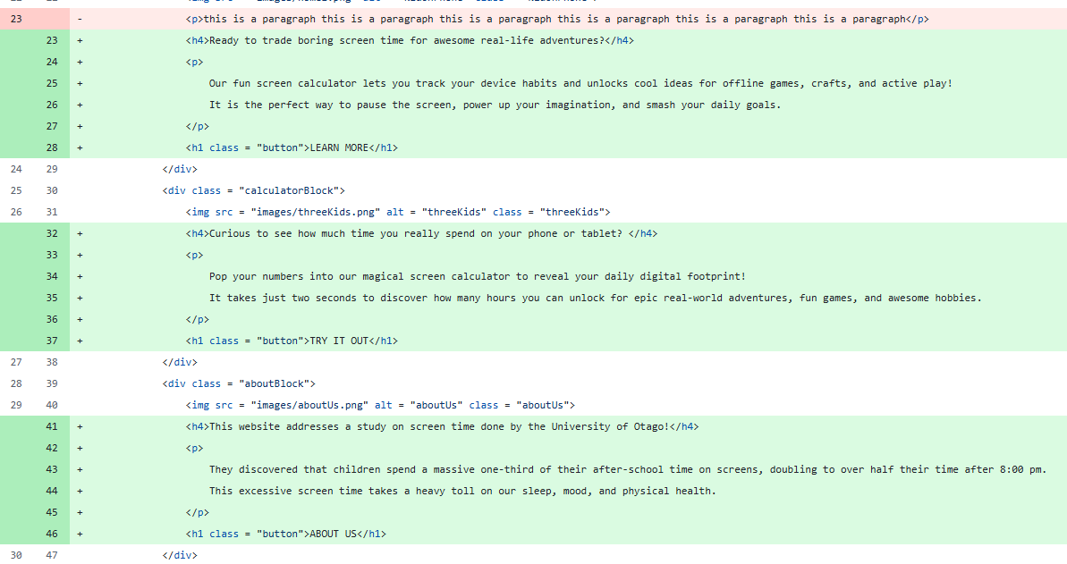
Navigation Bar | - Added website name | - Website name displays | Pass | - Did coding correctly | 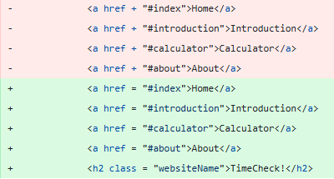
Navigation Bar | - Added website logo | - Website logo displays | Fail | - Did not set styles for logo image | - Add styles to logo image in styles.css
Footer | - Created footer in index.html  - Added copyright text  - Added styles in styles.css | - Footer displays  - Copyright text displays  - Styles inputted displays | Pass | - Did coding correctly | 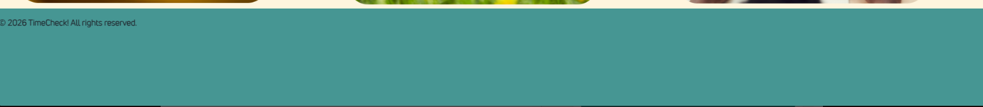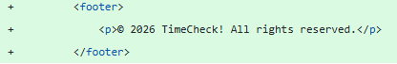

Iteration 3 – 4th August 2026
Component Tested | What I Did | Expected Result | Fail/  Pass | Reason for Fail/Pass | Proof (if Pass)/  What I Must Do (if Fail)
Homepage | - Updated hyperlinks for buttons to subpage files | - Subpage displays once respective subpage button is clicked | Fail | - Did not create subpage .html files yet | - Create .html files for the subpages  - Update hyperlinks to subpages .html files
Navigation Bar | - Updated ‘Home’ hyperlink to index.html | - Homepage displays once ‘Home’ is clicked | Pass | - Did coding correctly | 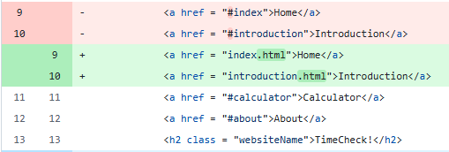
Overview Page | - Created introduction.html  - Copied the nav bar and footer from index.html  - Connected styles.css to introduction.html | - Nav bar displays  - Footer displays | Pass | - Did coding correctly | 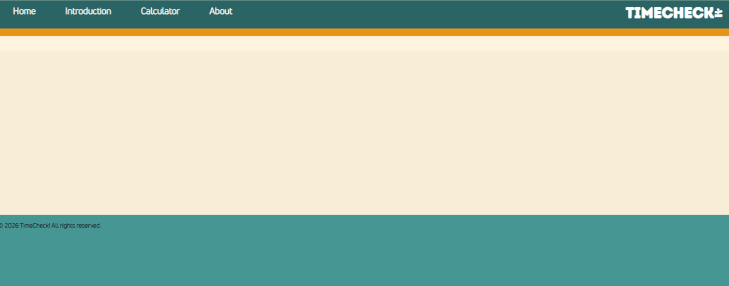  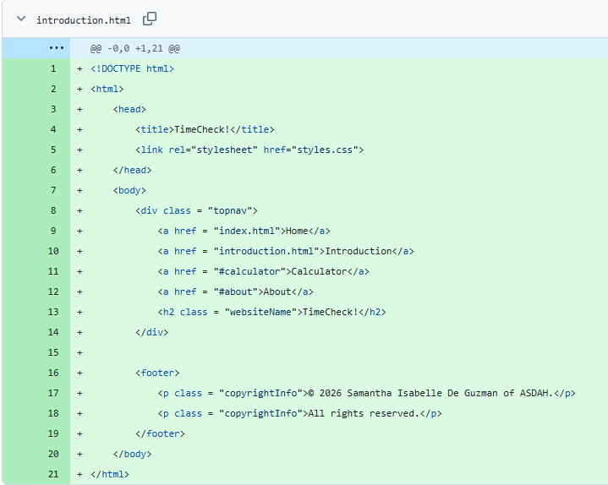

Iteration 4 – 5th August 2026
Component Tested | What I Did | Expected Result | Fail/  Pass | Reason for Fail/Pass | Proof (if Pass)/  What I Must Do (if Fail)
Footer | - Added ‘Contact Us!’ heading  - Updated copyright text  - Added email and contact number containers  - Added email and phone icons | - Heading displays  - New copyright text displays  - Email and phone number containers display  - Icons display | Pass | - Did coding correctly |   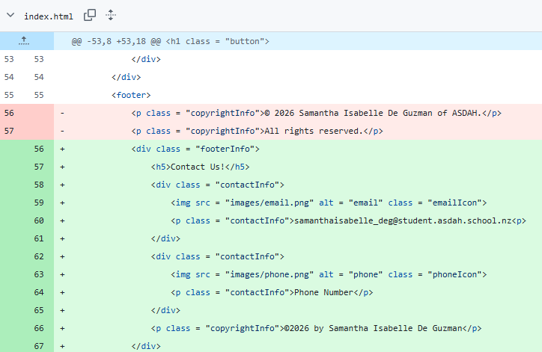

Iteration 5 – 6th August 2026
Component Tested | What I Did | Expected Result | Fail/  Pass | Reason for Fail/Pass | Proof (if Pass)/  What I Must Do (if Fail)
Homepage | - Updated button hyperlink ‘Learn More’ to ‘overview.html’ | - Overview Page displays once ‘Overview’ is clicked | Pass | - Did coding correctly
Navigation Bar | - Added website logo image | - Website logo displays | Fail | - Did not set float of image | - Set float of logo image to left
Navigation Bar | - Updated ‘Introduction’ to ‘Overview’  - Updated ‘Overview’ hyperlink to ‘overview.html’ | - ‘Overview’ displays  - Overview Page displays once ‘Overview’ is clicked | Pass | - Did coding correctly
Overview Page | - Updated file name to ‘overview.html’ | - New file name displays | Pass | - Renamed file

Iteration 6 – 7th August 2026
Component Tested | What I Did | Expected Result | Fail/  Pass | Reason for Fail/Pass | Proof (if Pass)/  What I Must Do (if Fail)
Navigation Bar | - Set website logo image float to left | - Website logo displays at left | Pass | - Did coding correctly | 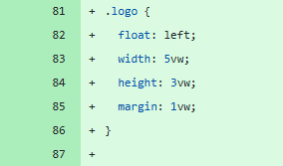
Navigation Bar | - Made page texts change colour when hovered by cursor | - Page texts change colour (white to yellow orange) when hovered by cursor | Pass | - Did coding correctly
Overview Page | - Added heading  - Added subheading for step blocks  - Added text paragraph for step blocks  - Added ‘Try It Out’ button | - Heading displays  - Subheadings display  - Text paragraphs display  - “Try It Out’ button displays | Pass | - Did coding correctly | 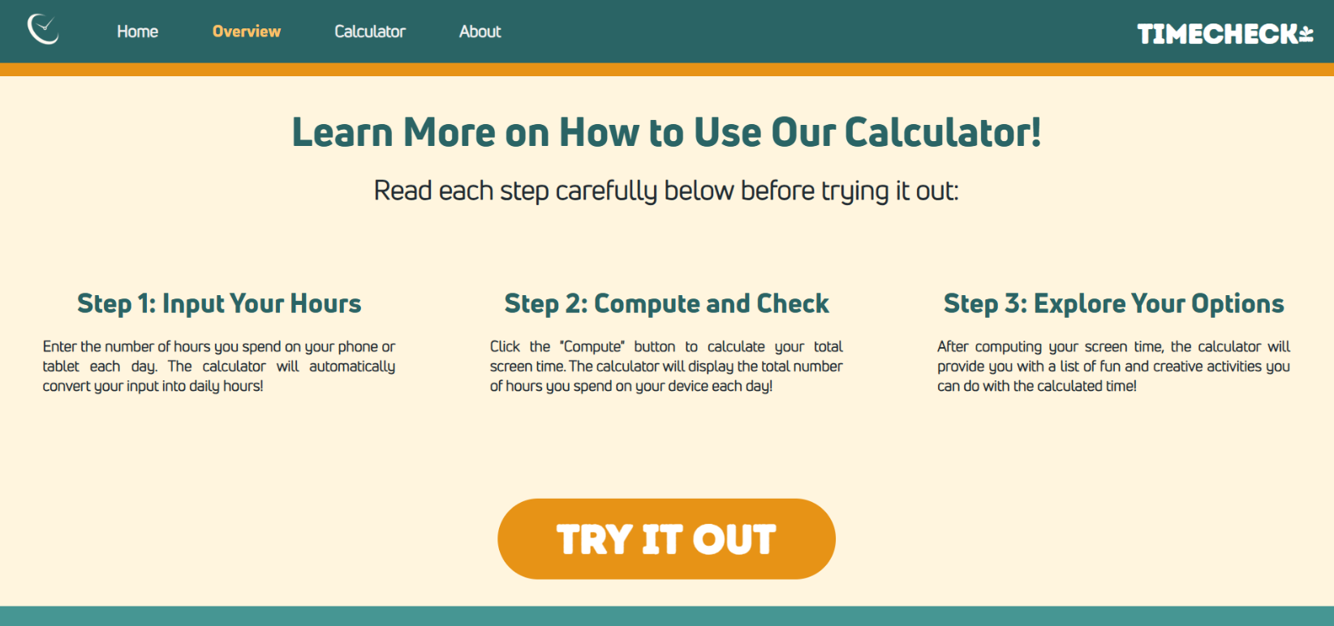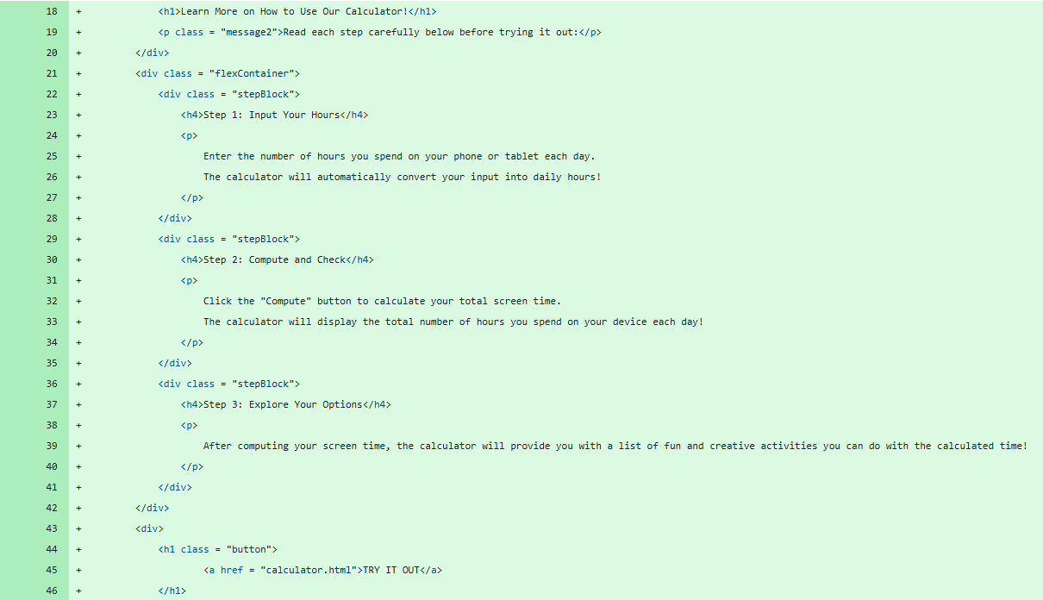
Calculator Page | - Created calculator.html  - Copied the nav bar and footer from index.html  - Connected styles.css to calculator.html | - Nav bar displays  - Footer displays | Pass | - Did coding correctly

Iteration 7 – 10th August 2026
Component Tested | What I Did | Expected Result | Fail/  Pass | Reason for Fail/Pass | Proof (if Pass)/  What I Must Do (if Fail)
Navigation Bar | - Updated ‘Calculator’ hyperlink to ‘calculator.html’ | - Calculator Page displays once ‘Calculator’ is clicked | Pass | - Did coding correctly | 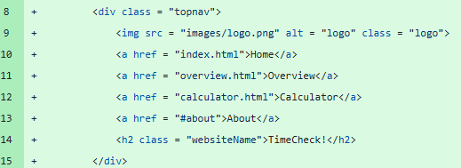
Overview Page | - Added image containers for instructional images | - Instructional images display | Fail | - Instructional images not captured yet | - Capture instructional images once calculator.html file is completed
Calculator Page | - Added table (2 columns, 11 rows) where users can input apps they used and the number of hours spent on each app  - Added column headings  - Added ‘Compute’ button  - Added text display for total hours  - Added styles in styles.css  - Connected script.js to calculator.html | - Table displays  - Headings display  - ‘Compute’ button displays  - Text displays  - Styles inputted display | Pass | - Did coding correctly  - Connected script.js using <script> tag | 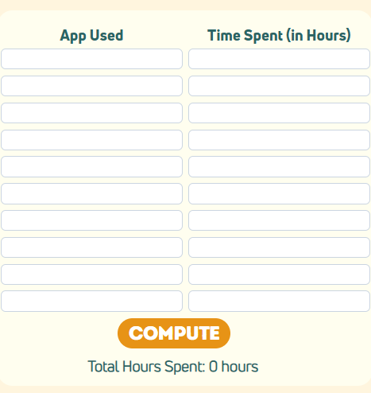  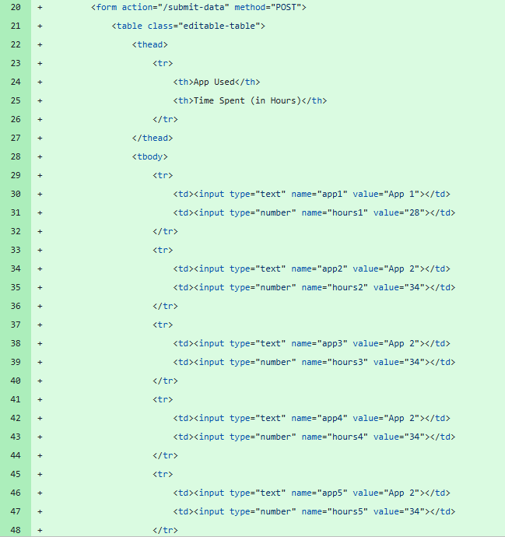
Calculator Page | - Created script.js for functionality part of page  - Added function for ‘Compute’ button | - ‘Compute’ button works | Fail | - Wrong syntax in constructing the function | - Redo function coding for ‘Compute’ button

Iteration 8 – 11th August 2026
Component Tested | What I Did | Expected  Result | Fail/  Pass | Reason for Fail/Pass | Proof (if Pass)/  What I Must Do (if Fail)
Calculator Page | - Updated subheading  - Fixed ‘Compute’ button function in script.js  - Added activity list block  - Added styles in styles.css | - New subheading displays  - ‘Compute’ button works  - Activity block displays  - Styles  inputted display | Pass | - Did coding correctly  - Used correct syntax for ‘Compute’ function | 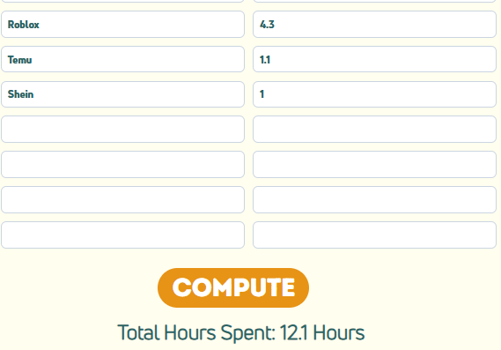  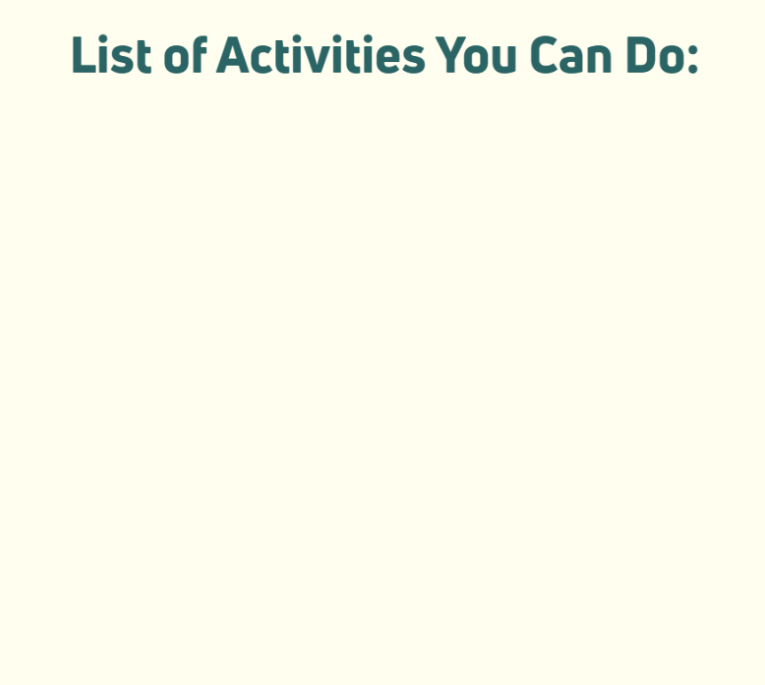  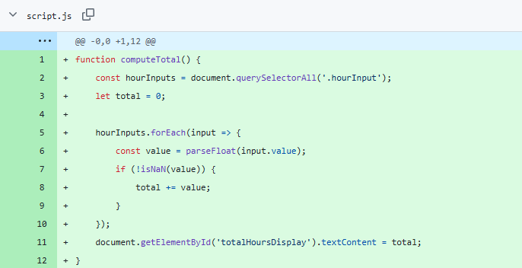
Calculator Page | - List of activities display depending on total number of hours computed | - List of Activities display | Fail | - Did not use conditional statements (if, elif, else) | - Add new function that uses the ‘Compute’ button function

Iteration 9 – 12th August 2026
Component Tested | What I Did | Expected  Result | Fail/  Pass | Reason for Fail/Pass | Proof (if Pass)/  What I Must Do (if Fail)
Homepage | - Changed block preview images to NZ-related images | - New images display | Pass | - Uploaded new images  - Did coding correctly | 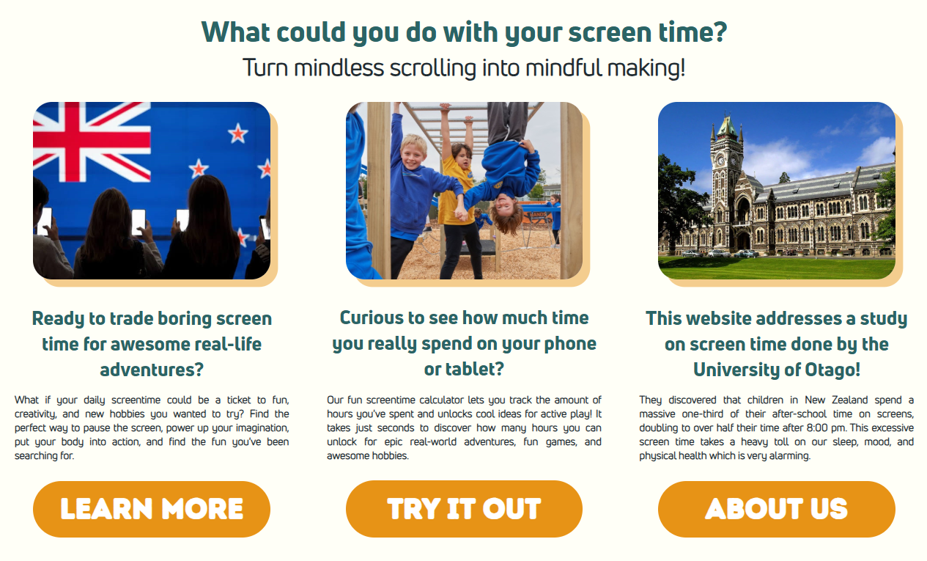
Calculator Page | - Added function for List of Activities to display | - List of Activities display depending on calculated total of hours | Pass | - Did coding correctly  - Integrated ‘Compute’ button function in the function | 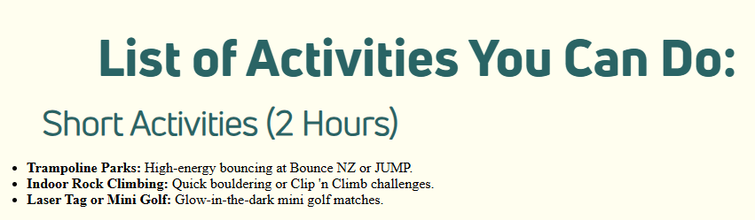  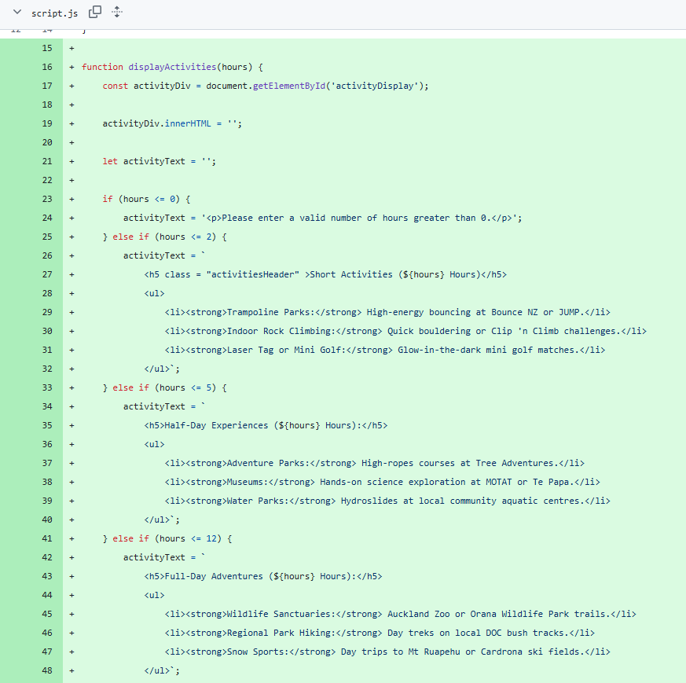

Iteration 10 – 13th August 2026
Component Tested | What I Did | Expected  Result | Fail/  Pass | Reason for Fail/Pass | Proof (if Pass)/  What I Must Do (if Fail)
Navigation Bar | - Updated ‘About’ hyperlink to ‘about.html’ | - About Page displays once ‘About’ is clicked | Pass | - Did coding correctly | 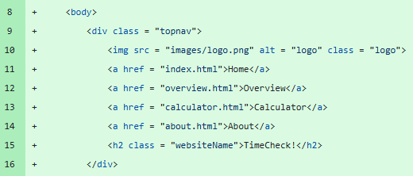
Overview Page | - Added instructional images in step blocks | - Instructional images display | Pass | - Uploaded images  - Did coding correctly | 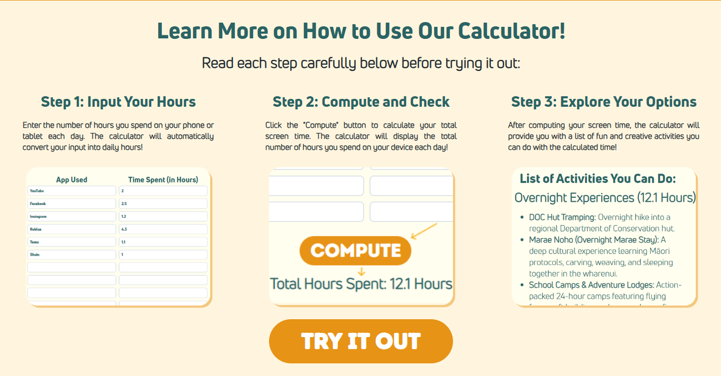  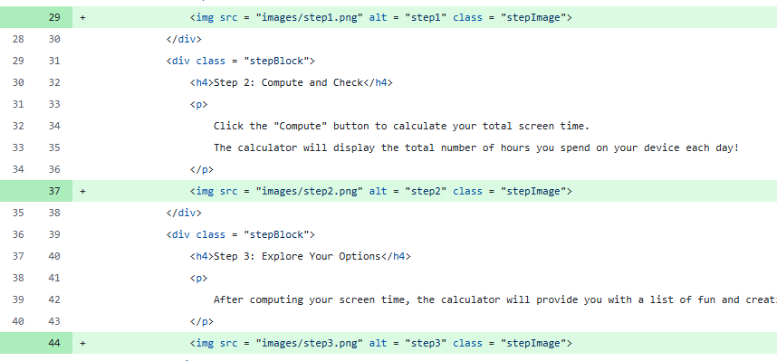
Calculator Page | - Added styles to List of Activities in styles.css  - Conducted multiple tests to see if different List of Activities depending on total hours computed displays | - Styles inputted display  - Different List of Activities display depending on calculated total of hours | Pass | - Did coding correctly  - Integrated ‘Compute’ button function in the function | 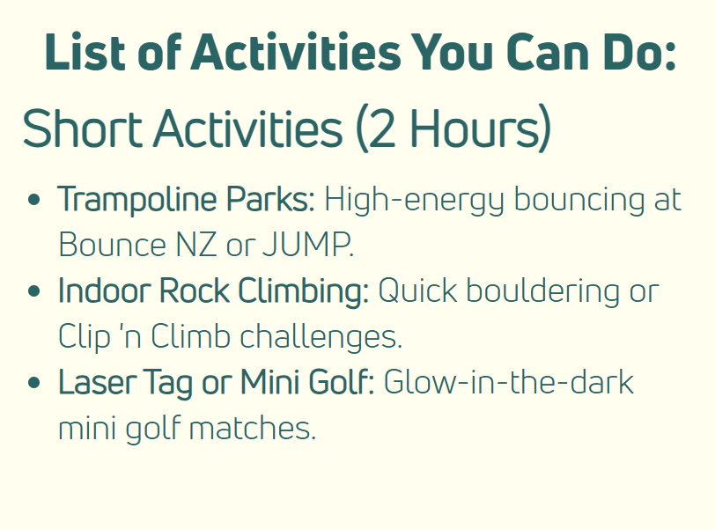  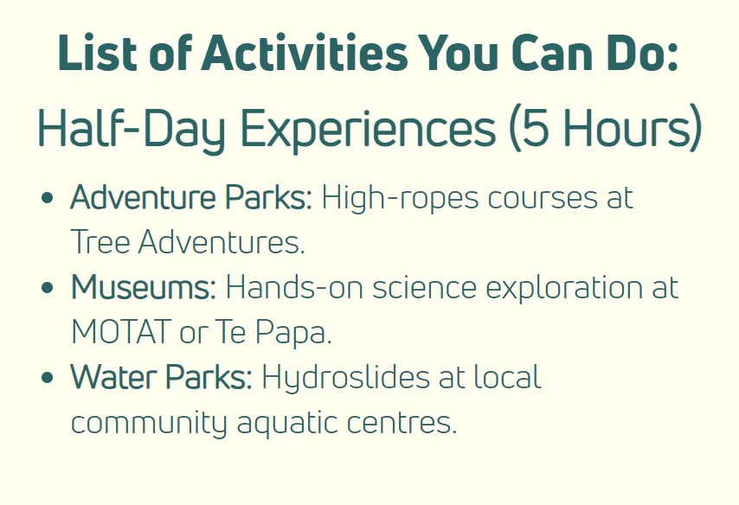  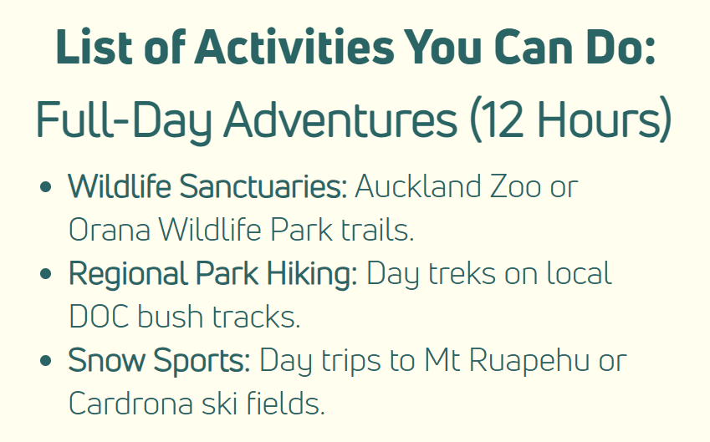  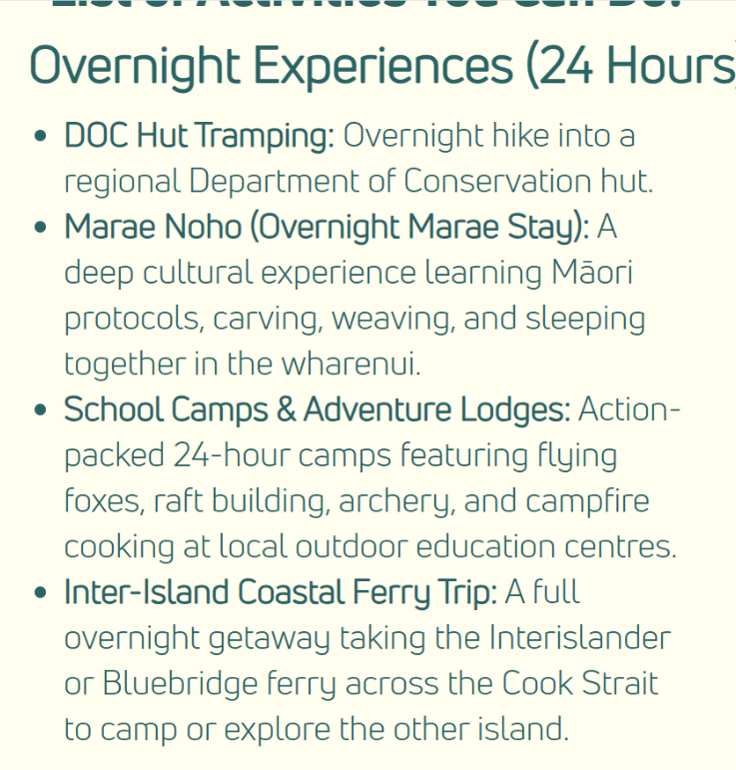
About  Page | - Created about.html  - Copied the nav bar and footer from index.html  - Connected styles.css to about.html | - Nav bar displays  - Footer displays | Pass | - Did coding correctly  - Connected styles.css using <link> tag | 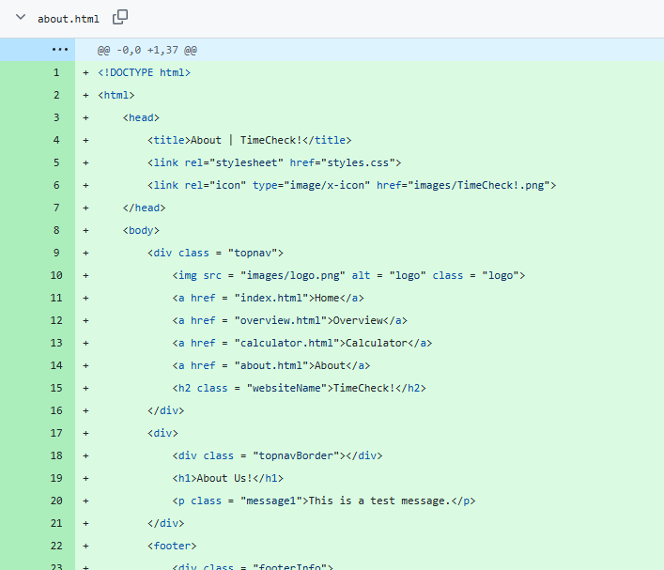

Iteration 11 – 14th August 2026
Component Tested | What I Did | Expected  Result | Fail/  Pass | Reason for Fail/Pass | Proof (if Pass)/  What I Must Do (if Fail)
All Pages (Homepage, Overview, Calculator, About) | - Changed background colour to a lighter colour in styles.css | - Background colour changes  - Text becomes more readable | Pass | - Did coding correctly | 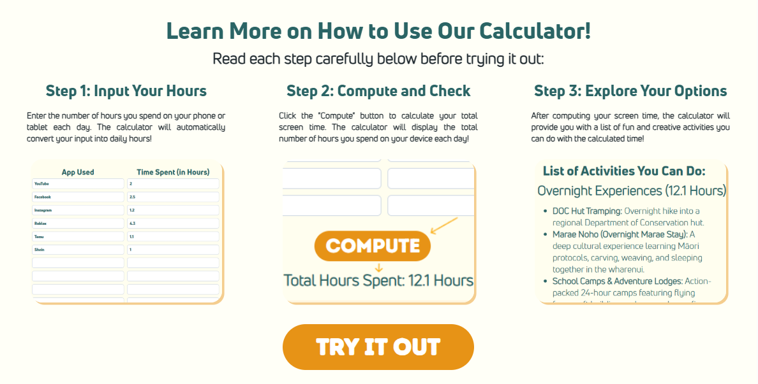  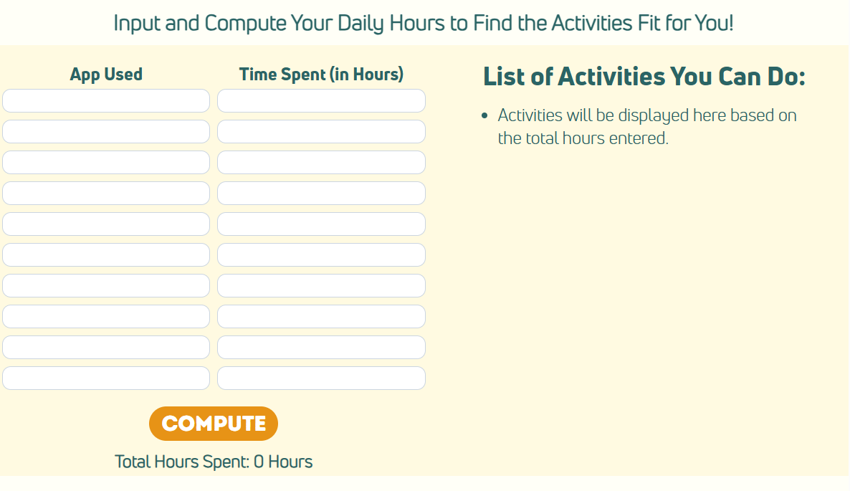    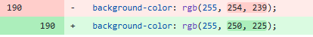
About  Page | - Added heading  - Added subheading  - Added text paragraph  - Added image of study researcher  -Added styles in styles.css | - Heading displays  - Subheading displays  - Text paragraph displays  - Styles inputted display | Pass | - Did coding correctly | 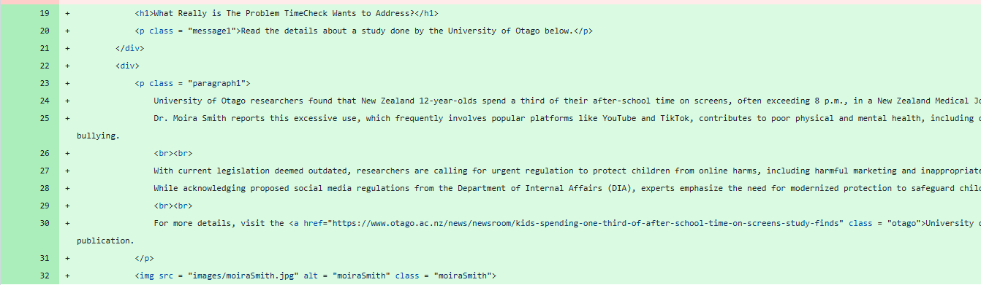
About  Page | - Added hyperlink for ‘University of Otago’ study | - Hyperlink redirects user to new tab when clicked | Fail | - Did not use <a href = “”> tag | - Use <a href = “”> tag and insert link of study

Iteration 12 – 17th August 2026
Component Tested | What I Did | Expected  Result | Fail/  Pass | Reason for Fail/Pass | Proof (if Pass)/  What I Must Do (if Fail)
About  Page | - Fixed hyperlink for ‘University of Otago’ study  - Added feedback section (heading, subheading, text area, ‘Submit Feedback’ section’  - Added styles in styles.css | - Hyperlink redirects user to new tab when clicked  - Feedback section displays  - Styles inputted display | Pass | - Did coding correctly |   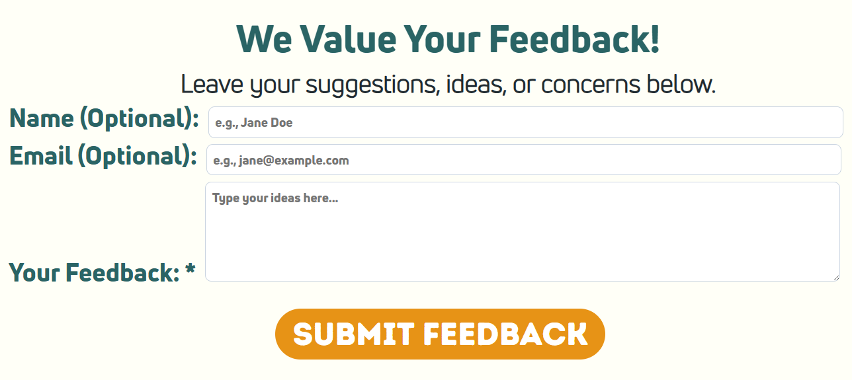  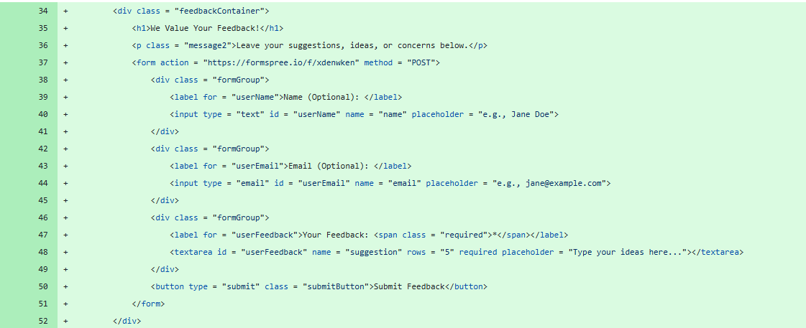
About  Page | - Made ‘Submit Feedback’ submit user’s input once clicked | - User input is submitted | Fail | - Did not use <form> tag | - Use <form> and find container for user feedback
Footer | - Added website logo and name to the right | - Website logo and name display | Pass | - Uploaded logo image  - Did coding correctly | 

Iteration 13 – 18th August 2026
Component Tested | What I Did | Expected  Result | Fail/  Pass | Reason for Fail/Pass | Proof (if Pass)/  What I Must Do (if Fail)
About  Page | - Added container for user feedback using Formspree.io | - User input is successfully submitted | Pass | - Did coding correctly | 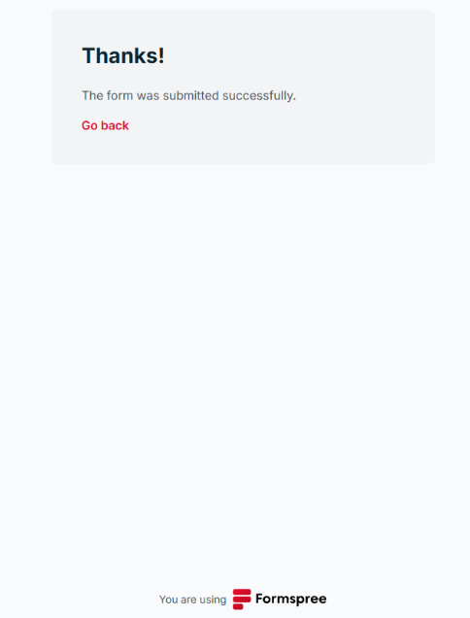  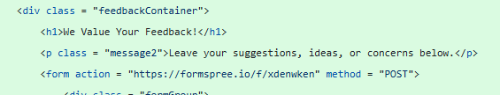
Footer | - Added subheadings to fill up space  - Added texts to fill up space  - Updated contact number | - Subheadings display  - Texts display  - New contact number displays | Pass | - Did coding correctly |   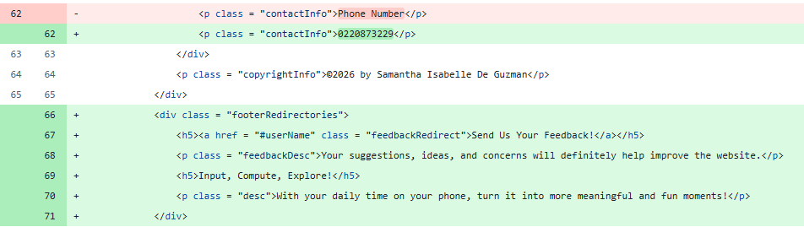

Iteration 14 – 20th August 2026
Component Tested | What I Did | Expected  Result | Fail/  Pass | Reason for Fail/Pass | Proof (if Pass)/  What I Must Do (if Fail)
All Pages (Homepage, Overview, Calculator, About) | - Added animation effect to website elements (fade in) in styles.css | - Animation effects display | Pass | - Did coding correctly | 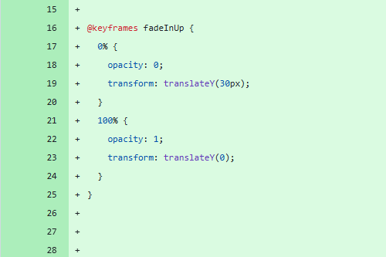

From 31st July to 20th August, the website is completed and all components have been developed and iterated progressively to achieve the best outcome.

Task 7: Develop and Test Outcome
After repeated tests, it showed the main purpose of my website was achieved as the user can calculate their daily screen time and look for alternative activities they can do instead. The user can also successfully use the feedback section to submit their suggestions and idea for the website.
Test Case | What do you expect to happen? | What happens? | What do you need to change?
User accesses the website | Website loads and displays in user’s screen. | Website loads clearly and displays as expected. | No changes were needed as repeated tests showed the website loads and is accessible once opened by the user.
User uses the navigation bar | Each button takes the user to the correct page. | Navigation bar works correctly and takes user to selected page. | No changes were needed as repeated tests showed navigation bar correctly directs user to selected page.
User reads the texts in website | Texts are clear and easy to understand. | Most texts are readable, but some are not. | Adjust character and line spacing and try different fonts that suit better.
User enters screen time hours in calculator | Calculator calculates and displays the total screen time accurately. | The total daily screen time is calculated and displayed correctly. | No changes were needed as repeated tests showed the correct total for different amounts of screen time.
User views alternative activities | Website displays a list of alternative activities suitable for the calculated time. | Website gives user a list of alternative activities based on total screen time computed. | Add more activity options to give users more choices.
User submits feedback through feedback section | User’s submits feedback successfully using the feedback section. | User submitted feedback promptly with no difficulty. | No changes were needed as repeated tests showed the feedback section’s functionality is good.
User completes the website’s main task | User can calculate their total daily screen time and understand what they need to do instead. | User can complete the main task without external help. | No changes were needed as the website’s main task is completed efficiently by the user.

Testing Images and Responsiveness
I also tested how the elements respond once the window changes in size. The default window resolution is 1920x1080 (in pixels) and the elements resize when the window resolution is equal to or less than 1050x1200 (in pixels). Some elements become smaller and remain in their position like the navigation bar, footer, and texts while some elements stack on top of each other such as the images and container blocks. The footer needs some fixing that it needs to reach at the bottommost part of the window but if it is positioned at the bottom of the window, the elements inside it will disintegrate. So, it will remain as it is for now.
Website  Page | Default Window Resolution  (1920 px × 1080 px) | Resized Window Resolution  (1050 px × 1200 px)
Home  page | 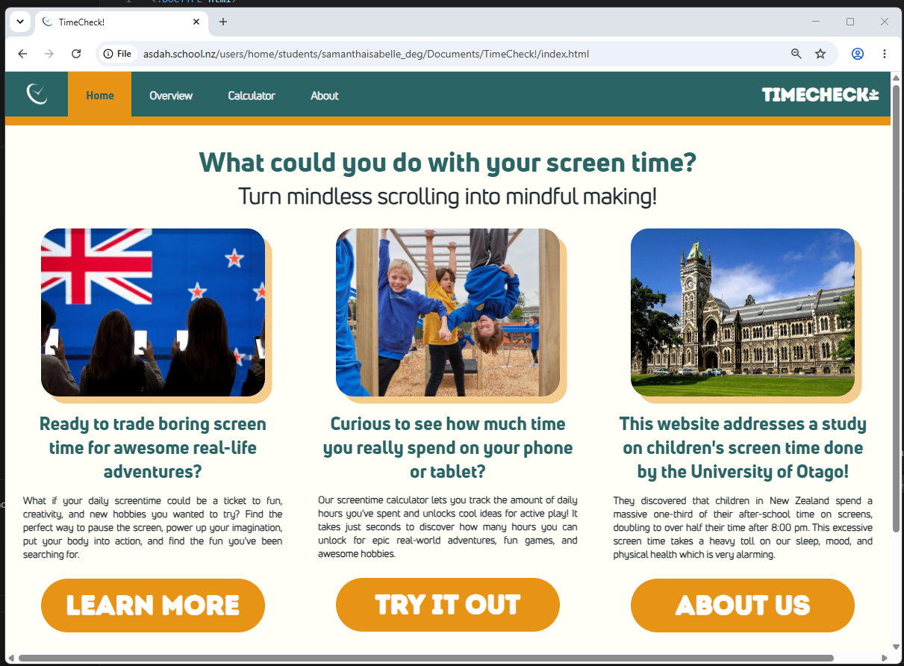 | 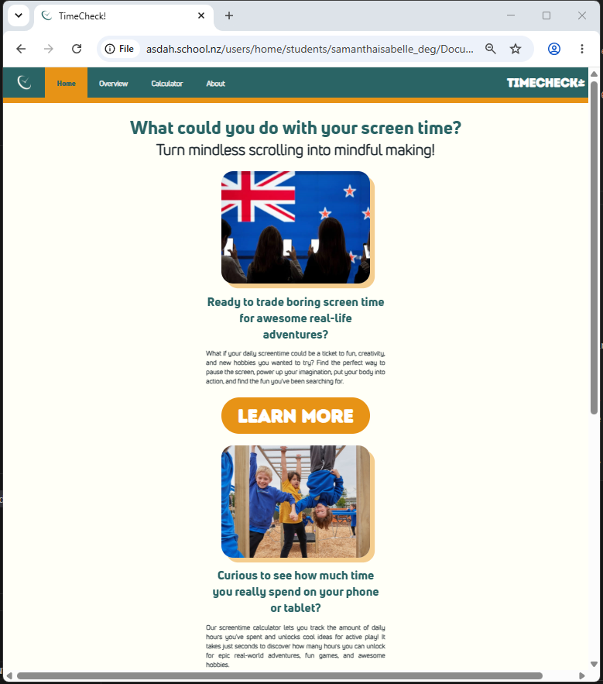
Overview Page | 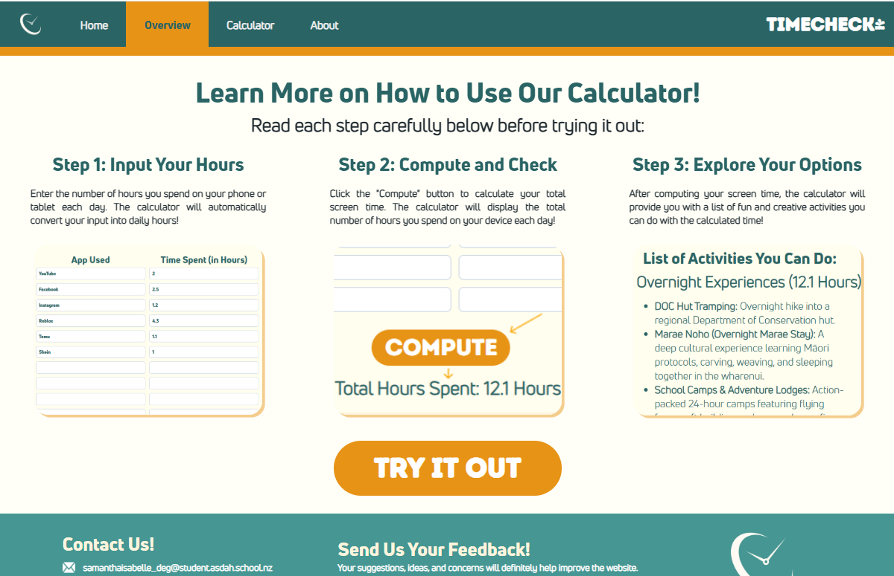 | 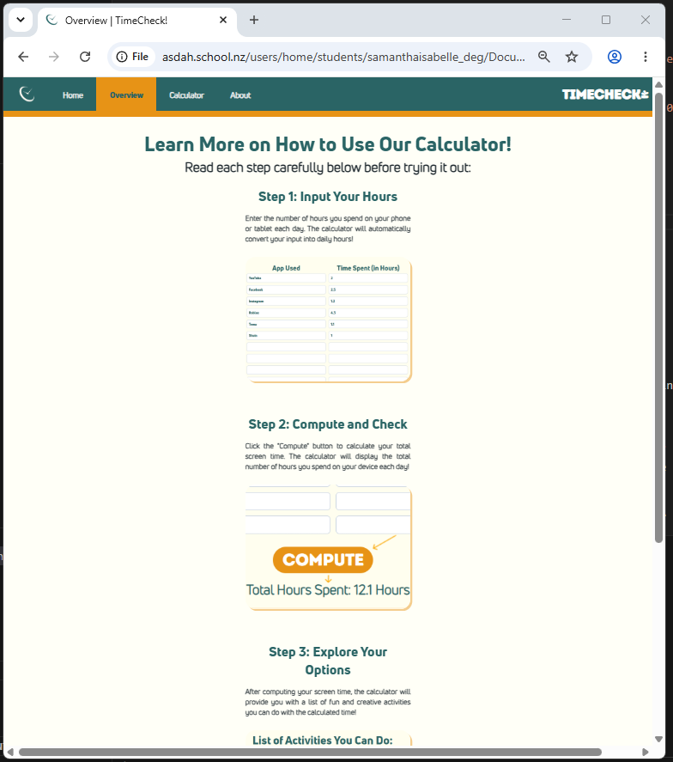
Calculator Page | 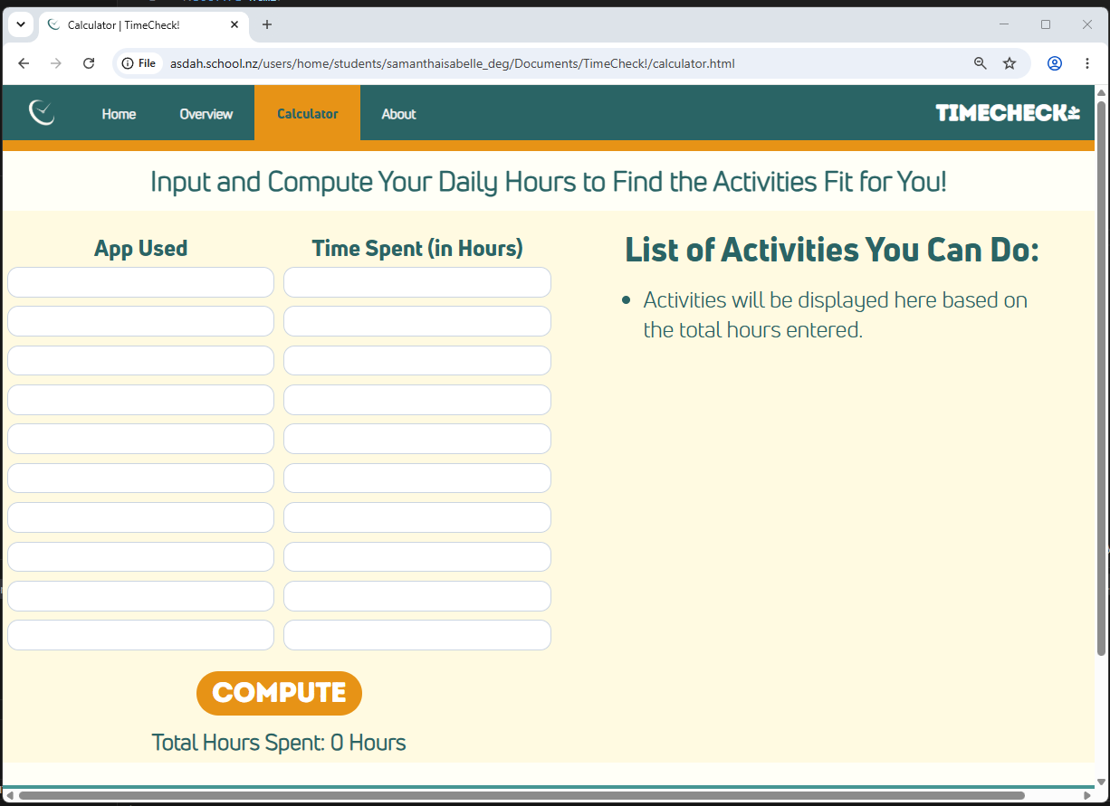 | 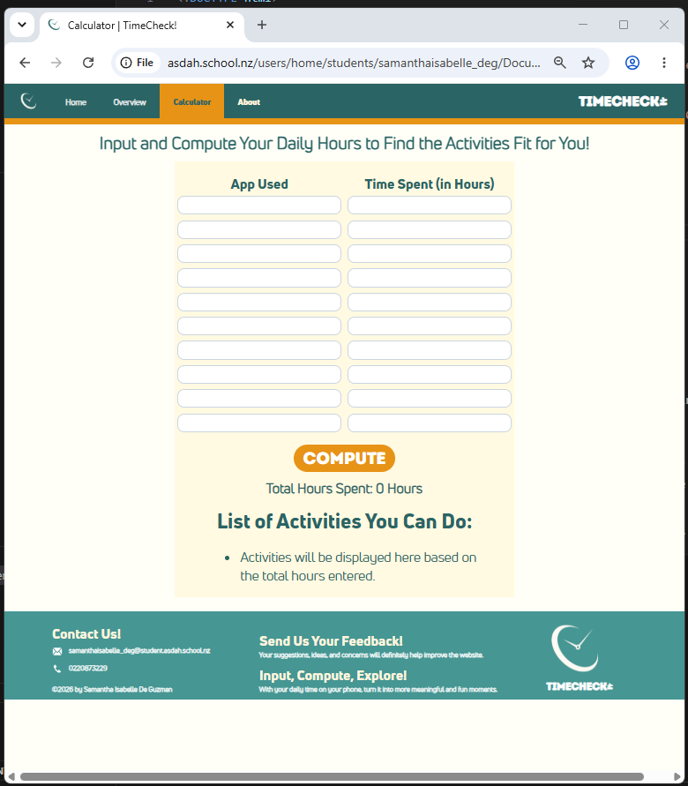
About Page | 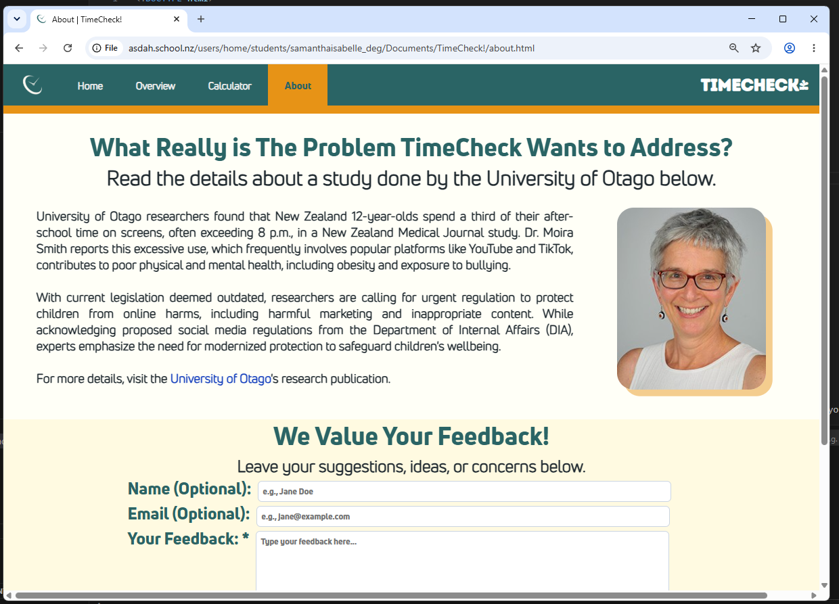 | 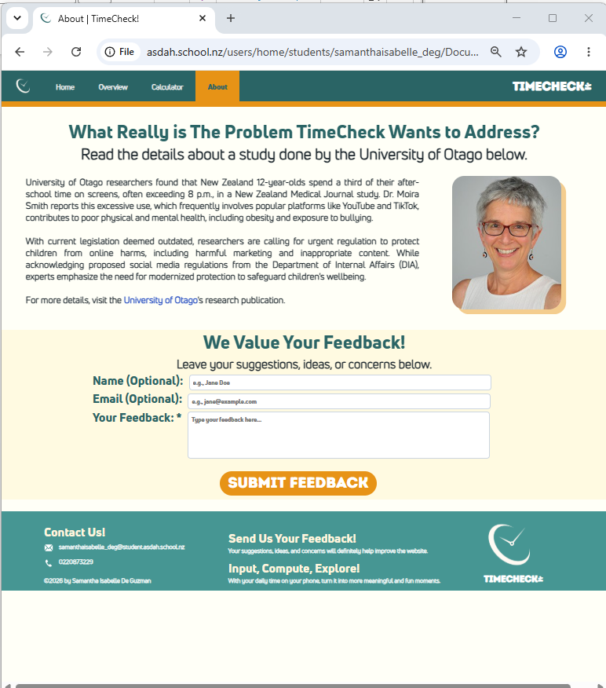

HTML and CSS Validation
HTML Validation Service: https://validator.w3.org/nu/#textarea
CSS Validation Service: https://jigsaw.w3.org/css-validator/#validate_by_input
Component Tested | Proof of Testing/Validating | Passed, or No? What needs changing?
Homepage  (index.html) | Before:  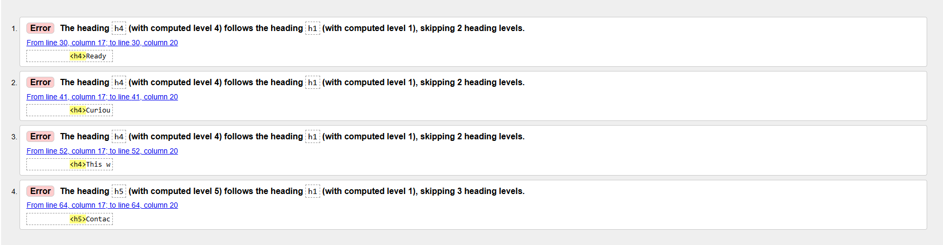  After: | X Not Passed  The headings used are not in the correct order convention (starts from <h1>). Instead, I used <h4> as the leading heading.  ✓ Passed  Changed all <h4> headings to <h1>.
Overview Page (overview.html) | Before:  After: | X Not Passed  The headings used are not in the correct order convention. Instead, I used <h4> as the leading heading.  ✓ Passed  Changed all <h4> headings to <h1>.
Calculator Page  (calculator.html) | Before:  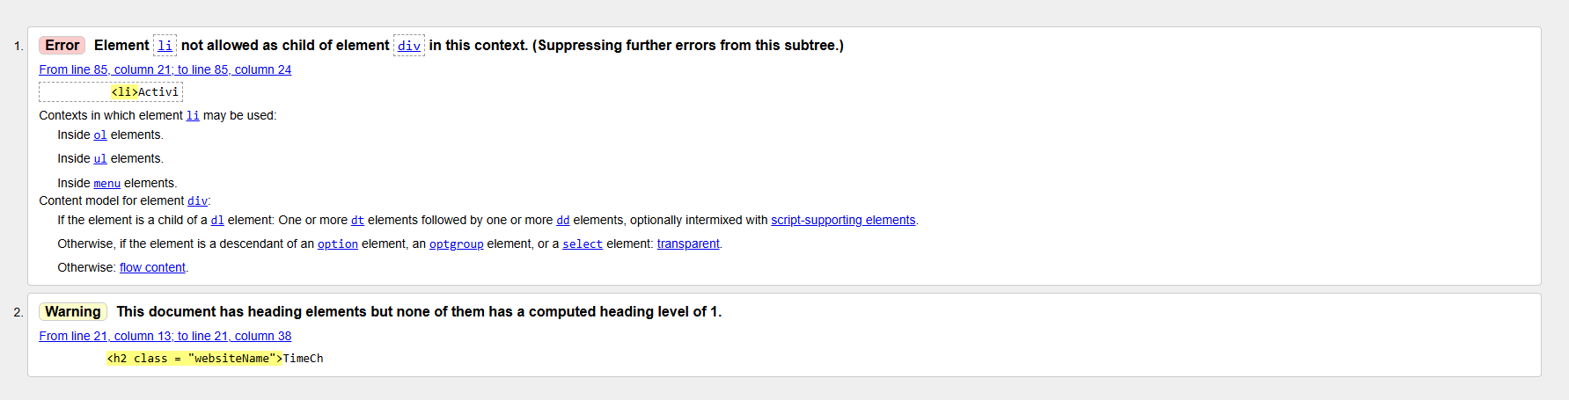  After: | X Not Passed  The unordered list (<ul>) items are not stored in a list (<li>) container. The heading used is not in the correct order convention. Instead, I used <h2> as the leading heading.  ✓ Passed  Added <li> container for <ul> items.  Changed all <h2> headings to <h1>.
About Page (about.html) |  | ✓ Passed  No changes needed to be made.
Stylesheet (styles.css) |  | ✓ Passed  No changes needed to be made.

Feedback
After finishing my website, I asked for feedback from three different people. Pseudonyms will be used for eacb person who gave feedback to protect their identities.
- Feedback of Person 1
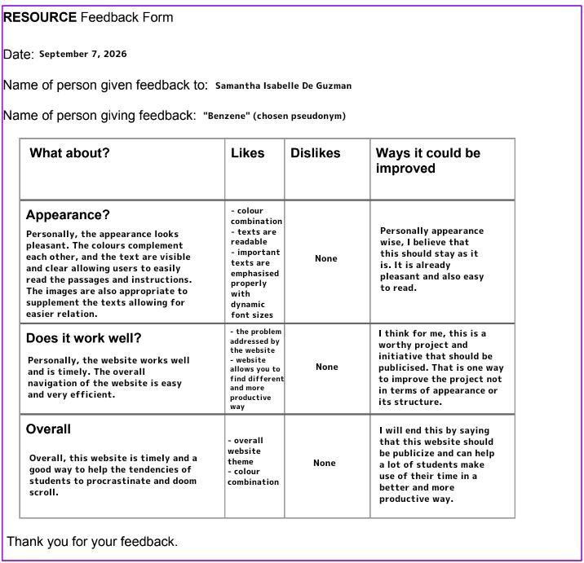
“Benzene” is a Year 13 student in New Zealand who tends to be on his phone all the time. He likes the overall website with its appearance and functionality. He also highlights the easy navigation, good colour combination choice, and visible texts. Lastly, he wishes for my website to be publicised to reach more users like him can use it and reduce their time on their devices.

- Feedback of Person 2
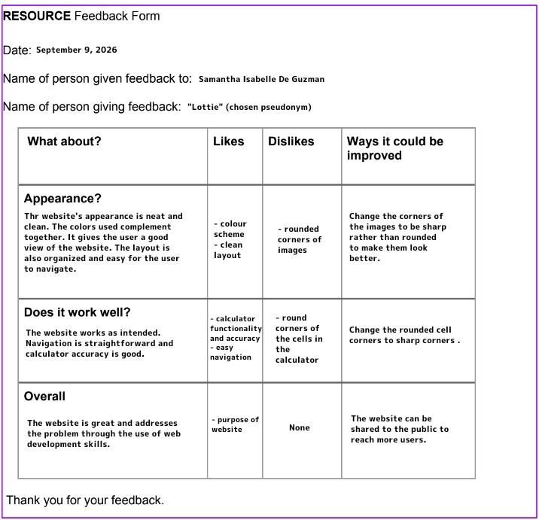
“Lottie” is a Year 11 student in New Zealand who just started taking up Digitial Technologies as one of her options. She comments on the clean appearance of the website and it works as how it is supposed to. Although, she prefers the corners to be sharp than round for some elements such as the images and cells in the calculator.

I tried removing the border radius for the images and calculator cells to match her preference, but it does not look any better in my opinion. So, I switched back to the original look of the images and calculator cells to make it look cleaner.

Overall, she likes the purpose of the website as it wants to address the problem of children being on their devices most of the time.

- Feedback of Person 3
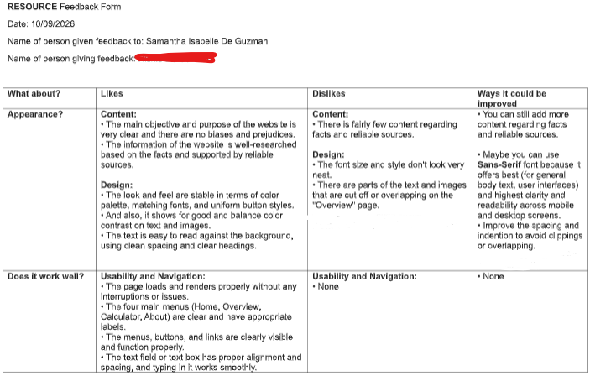
Person 3 is a professional software assistant manager in a software company. He provided a thorough and constructive feedback on the website. He highlights the website’s purpose is not biased and well-researched based on a supporting study. He also commends on the balanced design and layout being clean with a good colour palette and font choice. He suggested that the website could be improved by adding more content from more sources related to the current one being used, and to use the Sans-Serif font for better readability.

I tried changing the font from {} to Sans-Serif for all texts in the website.
Relevant Implications
- Legal Implication
TimeCheck needs to ensure the personal information of the users, such as from children between ages 8 to 15 years old, are protected as it is designed for them to use. I handled this by not requesting the users to input any personal information such as their names and ages and it must only the information needed to calculate their daily screen time which are the apps they used and their screen time hours on each app. This is useful as the users can comfortably use the website without the need of giving out any confidential information. Furthermore, I could improve this by including a notice that provides a clear statement of how users’ data will be managed by the website.
- Environmental Implication
The immoderate use of electronic gadgets such as mobile phones and tablets can result to high electricity consumption as they require electricity to work. TimeCheck aims to encourage users to switch from screens to doing recreational activities, which can help reduce unnecessary electricity consumption This is effective as my website provides different lists of activities based on the calculated total daily screen time of the users rather than reminding them to keep them away from their devices. As this aims to help reduce electricity consumption, the environmental impact could be further improved by suggesting activities that can benefit the environment such as tree planting and clean-up drives.
- Health and Safety Implication
The overuse of gadgets can affect a person’s well-being and result to being physically inactive. TimeCheck provides different lists of alternative activities the users can do after calculating their total daily screen time such as sports, exercises, and fun outdoor activities. This is effective as users can see how much time they have spent on their phones and devices and use that time to do something different that involves physical activity. I could further improve this by adding more activity options for the users to choose from that are doable, even at home.
- Social Implication
A huge amount of daily screen time minimises children to interact with people around them such as their family members and friends. With TimeCheck, it can help solve this problem by suggesting alternative social activities users can do with other people such as reading books and craftmaking. This creates engaging and meaningful interactions for the users, especially the children, as it replaces screen time. This could be further improved by adding more social activities that involves interacting within the local community.
Reflection

